(Approx. 1574 words)

President’s Column
Tech on Travel
By Greg Skalka, President, Under the Computer Hood User Group, CA
June issue, DriveLight
www.uchug.org
president (at) uchug.org

The summer travel season is upon us. Many of us will be taking trips, and a lot of the technology that we use at home will be traveling with us. All these devices and services can be a big help in planning a trip, navigating on our travels, getting information on local places and events, as well as staying in touch with others while away. We can also become slaves to our tech while traveling, however, lugging bags full of it with us, dealing with TSA inspections of it when flying and always worrying where our device's next charge will come from.

My wife and I recently took a long weekend trip to Northern California's wine country. We flew into San Jose and stayed four nights in a town south of Napa. We planned to visit some wineries and breweries, ride the Napa Valley Wine Train and visit a friend on our way back to the airport.

As usual, we used the Internet to plan and set up for our trip and took a bunch of devices and their accessories along with us. On our last vacation, a trip to Nebraska last August to see the total solar eclipse, I left my Windows 7 laptop at home. I brought so much camera gear that I decided to rely on my Chromebook for "big" computing, which worked out pretty well. The Chromebook is smaller and lighter, boots much faster and is my device of choice to go on the Internet. The Chromebook's main deficiencies are its lack of internal storage and lack of program support. While I can get email on the Chromebook through a web interface, I can't get access to archived emails as my email client, Thunderbird, won't run on it. I decided on this trip to take my total tech trio, the laptop, Chromebook and smart phone.

No matter which device I choose to access the Internet, all three can use the VPN (virtual private network) service I subscribe to, Private Internet Access. It allows me to surf securely on public airport Wi-Fi and use hotel internet connections with more privacy. I didn't use it too much with my smart phone, using it only when connecting to the hotel Wi-Fi. I used the VPN a lot with my Chromebook, in airports and other Wi-Hotspots. On my laptop, I tried to use it to buy concert tickets from our hotel room, but the Ticketmaster web site wouldn't work with the VPN on. Fortunately, the https connection to their site allowed me to conduct the transaction securely without the VPN.

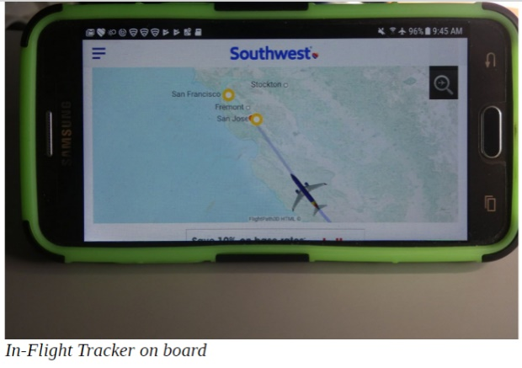
We had some wait time in the San Diego International Airport before boarding to leave, so I searched for a good lunch spot to use once we arrived in San Jose. I was able to use the free airport Wi-Fi to find a good brewpub in Redwood City that was on our expected route to Napa, was going to be open, and had food and beer that appeared acceptable.

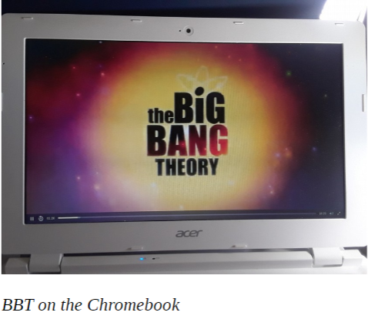
Once on the plane, I found Southwest had made some improvements to their in-flight Wi-Fi services. It appears they have now rolled out Wi-Fi to all their planes. On our flight to Nebraska last year, I was not able to access their in-flight TV or movies (even the free ones) on my Chromebook, as they only supported Windows, iOS and Android devices. Now they have added support for the Chrome OS, as I could connect and view free episodes of the Big Bang Theory and other recorded and live TV video. Unfortunately, I forgot to bring headphones, so I had to wait to watch until the return trip, after I'd bought some cheap earbuds.

There are some great Bay Area tech museums, which are worth the visit if you are in the area. The Intel Museum in their Santa Clara headquarters has displays of the evolution of their processor and storage technologies. The Computer History Museum in Mountain View has excellent displays covering computing technology from the abacus to today's modern devices; you can easily spend hours there.
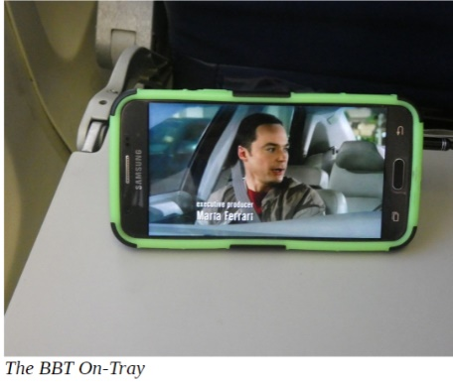
One tech landmark I've not yet visited but would like to is the original garage in Palo Alto where William Hewlett and David Packard started HP. Though the residence and garage are now owned by HP, they are not open to the public; you can see the garage from the street, however. The Bay Area is also the corporate home for many big tech companies, including Google, Groupon and Apple. I didn't get to visit any of these places on this trip, however, as my wife was more interested in wine than microcircuits.

Fortunately, I did need those ear buds for the flight home, so I was allowed to stop at a Fry's Electronics store along the way. Fry's was born in Silicon Valley, and there are many stores in the area to visit. Each is "decorated" in a different theme, with many related to the technology developed in Silicon Valley. We stopped in the Fry's store in Palo Alto, which has an old west theme.
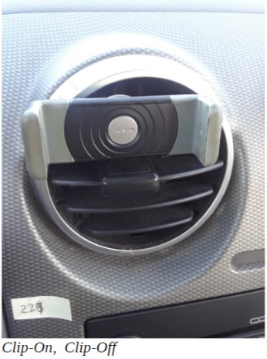
For navigation on this trip, I decided to use only Google Maps on my smartphone and leave my Magellan auto GPS receiver at home. Google Maps worked great, providing routing, traffic information and navigation, as well as busines s info (opening hours, etc.). The essential accessory for navigating with a smart phone is a phone vent clip, which attaches a smartphone to the dash of a car at an air vent grill. I use this kind of clip on all on my own cars; it also worked well on our rental car.

While Google Maps uses the GPS receiver in your smart phone for location and velocity, it relies on the cell phone data connection (radio link with cell towers) to show maps, perform routing and provide traffic and landmark information. This creates a problem for use in areas that have poor or no cell coverage. Google appears to have improved Google Maps for trips in these areas, however. On one of our trips north to Santa Rosa, the Maps app indicated that some of our route was subject to poor cell coverage, and it would download map data in the background to use in those areas. This issue has been a concern of mine, as I found on our trip to Nebraska last year that cell phone coverage can be spotty or non-existent off the Interstate highway in rural areas (which is most of Nebraska). On that trip, I used both the phone and GPS receiver, with the GPS (using stored map data) providing the directions in some rural areas. I can see how downloading map data to the phone could work for trips started in areas of good coverage, but it seems that starting a trip in an area with no phone service would still be a problem.

There are a lot of bridges in the Bay Area, and most have tolls, though often in one direction only. Most bridges still accept cash for tolls, but the locals generally use electronic radio transponders in their cars to track their bridge tolls. Our Budget rental car was equipped with an eToll electronic toll transponder, which can be used to pay tolls through the car rental contract. The problem I found with their eToll system is Budget's big service charge to use it; we avoided the issue by crossing bridges in the free direction only. Google Maps can help with this if set to avoid tolls when selecting routes.

We had complimentary Wi-Fi in our hotel (we stayed in the DoubleTree by Hilton, in American Canyon, which is about 10 miles south of Napa), but I initially had problems connecting some of the five different devices we brought. The hotel’s Wi-Fi radio link had no encryption; you had to enter your name and room number in an initial web page to complete the data connection and access their network. My problem was in getting that initial Hilton log-in page to come up on some of my devices. All I would get was some error message on my Google home page. After bringing my Chromebook to the front desk, a tech-savvy clerk was able to give me the tip I needed to connect reliably to their Wi-Fi. Something about Google's web page (the home page on the Chromebook) would not allow the Hilton page to automatically come up. Entering any other URL (for Yahoo, or even UCHUG) brought up the log-in page every time.

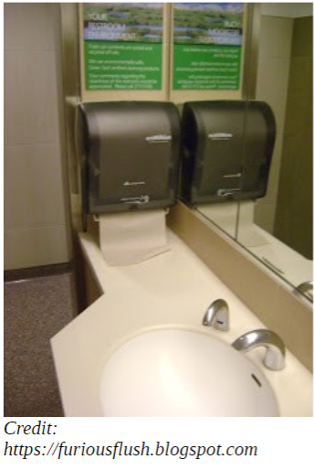
The San Jose International Airport is high-tech, which is appropriate considering it is the air hub for Silicon Valley. I used an airport restroom before boarding the plane to return home and found it to be very clean. Perhaps this was due to the sticker on the lavatory mirror, which listed a number and asked customers to text a message to it if the restroom needed to be serviced (text to get soap or paper towels refilled, for example). The sticker had a number to include in the message to indicate the restroom location.

Our technology safely made the trip to Napa and back and helped us along the way to have a better vacation. Unfortunately for our tech items, only we humans got the frequent flyer points.

[Photos credit the author except as noted.]



